**WordPress Plugin Development**

**What is plugin inside wordpress**

**Plugin**

- is a piece of software that adds specific features on functionality

- allows to extend and customize some side functionality without writing any code

- plugin can do wide range of things such us improving SEO of our website, adding contact form adding sliders and much more security things.

- so basically enhance or adds some specific functionalities

> in this course you have some idea about my simple or SQL database queries like CRUD

>have some idea about jQuery and HTML

**In this course goal to create 12 number of different types of custom plugin.**

1. **Hello World Plugin**

* You will know to write USP Comment lines so that our first plugin will be introduced inside WP.
* Additionally well know the concept of admin dashboard widgets.

1. **WP ShortCode Plugin**

* You will know the concept of what is shortcode types of sort code, why we use sort code inside WP, how to write and execute sort code.

1. **CSV data uploader**

* For example we have a CSV file inside that CSV dile we have multiple of datas. What we want we we want to insert that data into a table of Wordpress.
* In this plugin we learned how to Create a dynamic database table.
* And once it will created so how to get CSV data how to pass and save inside that table well know and get all the concept inside.

1. **Table data backup to CSV**

-by the help of this plugin well dump all the table data into the CSV File. For example lets say that we have an employees table and inside that table we have multiple employess data. WHAT WE WANT we want to export of data into the CSV file.

1. **Wordpress Custom Widgets**

* We learnd about widgets, why we use widgets and the process.
* Well know the complete about widgets.

1. **SEO Meta Tags Plugin.**

* Well create a custom meta boxes inside WP post types so whenever we fill any info inside those boxes how to save, render those value inside front end.

1. **WP Admin Login Page Customizer**

* Well know the concept of settings fills inside WP and how to customize like LOGO, TEXT COLOR, BG etc….
* Learn how to control

1. **WP CRUD Plugin Development**

* Learn CRUD statements

1. **WooCommerce Product Creator.**

* Well create an Ecommerce product
* What is ecommerce class, methods and etc.

1. **.WooCommerce Product Importer (CSV)**

* Learn how to import multiple products using CSV files

1. **WP Plugin Generator tool.**

* Online tool that help to generate any plugin inside WP.
* We can generate some skeleton of plugin folders and file by the helf of this we can easily manage and create WP plugins

1. **WP JSON rest APIs**

* Once we create and activate so automatically will create some rest API and points inside WP.
* By the help of this we can perform all the CRUD Operation .

**IMPORTANT TO INTERVIEW**

* **How many tables create dynamically while activation or while installatation the answer si 12**

1. **Hello World Plugin**

First, Open WP in editor VSCODE

* Shortcut to open. Go to folder projects, right click. Open terminal and type “code .”
* You go to vscode

To create a plugin folder go to wp-content > plugin and create folder name with “hello-world-plugin”

**hello-world-plugin (folder)**

* Create first file hello-world-plugin.php

**hello-world-plugin-php**

<?php

/*

 * Plugin Name:       Hello world

 * Description:       This  is my First Plugin which create some information widgets to admin dashboards

 * Author:            John Smith

 * Version:           1.0

 * Author URI:        https://author.example.com/

 * Plugin URI:        https://example.com/plugins/the-basics/

 */

* This comments line are very important to introduce our custom plugin into WP setup

**Heres the original based of wp org.**

/*

* Plugin Name: My Basics Plugin

* Plugin URI: https://example.com/plugins/the-basics/

* Description: Handle the basics with this plugin.

* Version: 1.10.3

* Requires at least: 5.2

* Requires PHP: 7.2

* Author: John Smith

* Author URI: https://author.example.com/

* License: GPL v2 or later

* License URI: https://www.gnu.org/licenses/gpl-2.0.html

* Update URI: https://example.com/my-plugin/

* Text Domain: my-basics-plugin

* Domain Path: /languages

* Requires Plugins: my-plugin, yet-another-plugin

*/

* Now Check your Custom sample plugin in Dashboard. It saved the informations



**Two basic concept of plugin**

1. **Admin Notices**
2. **Admin Dashboard Widgets**
3. **Admin Notices**

* Is an action Hook by the help of that we can control messages to show out admin for example in case of success, *success to saved a data*. So the message will be data saved successfully. Or in case of error the message will *be failed to save data*.

First add action

add_action(“admin_notices”, “”) > second parameter is important kasi eto ung mag hahandle ng callback activity example we want to display messages so ung action mo is admin_notices so the second uun ung mag hahandle. It is using function.

add_action(“admin_notices”, “hw_show_message”);

function hw_show_message(){

echo ‘<div><p>Data Saved of Hello World!</p></div>’;

}

**ALSO ACTIVATE FIRST YOUR CUSTOM PLUGIN.**

Now it works and notice no CSS Classes. The Default id BOOTSTRAP.

add_action("admin_notices", "hw_show_message");

function hw_show_message() {

    echo '<div class="notice notice-success is-dismissible">

        <p>Data Saved! Hello World!</p>

    </div>';

} ADD SOME CSS CLASS FROM BOOTSTRAP.



**I add for errro message. Exmple**



1. **Admin Dashboard Widgets**

* If you go in the dashboard you see some activities, site health status, events draft and etc… un ung mga widgets.
* First add action first then function
* The hook is “wp_dashboard_setup”

add_action(“wp_dashboard_setup”, “hw_hello_world_dashboard_widgets”)

function hw_hello_world_dashboard_widgets(){

dito na ung wp_add_dashboard_widgets.

}

Go to wp_add_dashboard_widget() google search

This a format code that automatically create a widgets in dashboard.

The widget id, name and callback are important ang the rest is optional.

1st parameter is the id mo. Which is should be unique.

2nd parameter is ung Name ng widgets mo. Ung mag didisplay na name.

3rd parameter is the callback – it decide what activity or message of that widgets. So basically function name sya, and I cacalll mo sya sa function.

Example your callback name is hw_custom_admin_widgets

The function hw_custom_admin_widgets(){

echo ‘This is Hello World Custom Admin Widgets’;

}

**EXAMPLE for Admin dashboard widgets**

**2. WP Shortcode Plugin**

First create also a folder in plugin **shortcode-plugin** the add file **shortcode-plugin.php**

file **shortcode-plugin.php**

<?php

/*

 * Plugin Name: Hello world

 * Description:       This  is my second Plugin which create some information widgets to admin dashboards

 * Author:             John Smith

 * Version:           1.0

 * Author URI:        https://author.example.com/

 * Plugin URI:        https://example.com/plugins/the-basics/

 */



Remember: deactivated then first plugin and activate your second plugin

What is the shortcode?

* Something like a sand operator means a sand message

Example [message] > this is a short code

* Once we use sort code inside page inside anywhere or wordpress so what the function we need what we want to execute siply by putting a callback function.
* So basically is like a sand operator we can render ANYTHING INSIDE WORDPRESS
* Creating shortcode need to wrap that as bracket []. Ex. [message]
* And we need to us a wordpress function called add_shortcode

**1st Concept(Basic Shortcode)**

Adding shortcode it suggest automatically the required parameter. Example (“message”, “sp_show_static_message”)

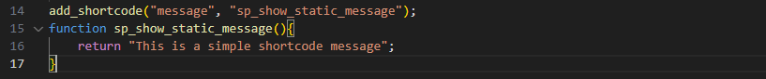

[message] remember if you want to call the sortcode use this format

Now lets try:

Create a page > add title > in paragraph type “/” > may nakalagay na Shortcode then inside sa WP or dun sa page dun mo ilalagay ung shortcode mo [message].

* Used return instead of echo kasi pag echo instead under the title ung message malalagay sa pinaka taas

Example is this:

Then you can customize and add some css in the message. Like this

**2nd Concept namans (SHORTCODE WITH PARAMETERS**

**)**

What is parameterized code and how to create and use inside applications

What is parameterized > using **[message name=”john” email=””]** >once na ganto daw its called ass parameterized ShortCode - how to handle and get this parameters while defining.

Example. First create add action.

//[student name=”John” emal=”John”] may parameter values

add_action(“student”, “sp_handle_student_data”);

function sp_handle_student_data($attributes){ > by the help of att well received all the parameter values

then sa loob may shortcode atts

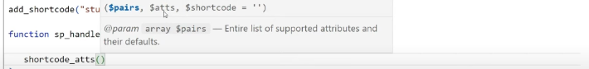

Pairs = means the default value of parameters what we are passing while calling shortcode

Atts = what parameters we are receiving

Shortcode – is option is it what the shortcode name.

So example

shortcode_atts(array(

“name” => “default Student”,

“email” => “default Email”

), $attributes, “students”)

After this copy attributes make it like this.

$attributes = shortcode_atts(array(

“name” => “default Student”,

“email” => “default Email”

), $attributes

Then return

return “<h3>Student Data: Name – {$attributes[‘name’], Email - {$attributes[‘email’]}”

}

EXAMPLE:

See the default? Kasi wala value ung [student] ko.

Pag may Value

You can also **style** that.

REMEMBER if you want to add more parameter you have to add first in the **shortcode array**.

**3nd Concept namans (shortcode with db operation)**

* Well render some dynamic data from database.

This time concept gagamit tayo ng Global database ng wordpress

**global database** typically refers to the central database system used by WordPress to store and manage all the data for your website. WordPress uses a MySQL (or MariaDB) database by default. When discussing "global database" in the context of WordPress, it can also refer to the way database operations are handled via the $**wpdb** global object.

By the help of this well make a query to post table to fetch all the data of post what we have saved inde the post.

SO BASICALLY KUKUNIN NATIN UNG MGA LAMAN NG POST.

* Add some post page.
* And look for the database wp_post in laragon
* Notice that they saved your post there. So basically may database sya. You can access them if they have you can get the title even the date etc.

NOW THE ALTERNATIVE

1. **CSV data uploader**

* In this plugin we’ll create a shortcode > by the help of this we’ll render a form where we upload a CSV data file.
* Once we upload simply we need to pass all the data and save all those data inside a custom created dynamic database table

Create a folder csv-data-uploader add file csv-data-uploader.php inside that file include comments which is the details of your plugin.

This is the example if it works the shortcode.

add_shortcode("csv-data-uploader", "cdu_display_uploader_form");

 function cdu_display_uploader_form(){

    return "<h3>CSV Data Uploader</h3>";

 }

* Add new page CSV Data Uploader then lagay mo dun ung shortcode mo [csv-data-uploader]
* Now it works but instead of static message we want to display a form here.

Always Remember deactivate the last plugin then activate this newest plugin that you created:

NOW..

Define first a constant

Using this  **define("CDU_PLUGIN_DIR_PATH", plugin_dir_path(__FILE__));**

* Then create a new folder in the csv-data-uploader >**template** name because we create a single file. And inside the **template** create a file cdu_form.php.
* Inside cdu_form.php create a code like static **<h3>FORM DATA</h3>**
* Now you need to access that file
* Using echo CDU_PLUGIN_DIR_PAT;die A screen shot of a computer program

  Description automatically generated



You see the access file you need to add the /template/cdu_form.php inorder to access to that file.

In order to Access to that file you use Start PHP Buffer.which is ob_start()

Now it Access the file.

Go and make a form data codes in cdu_form.php

Like this:

* Now we have Form data you can add some css to become eye catching form data but were not focusing in css. But how to handle the functionalities inside plugin development inside wordpress.
* Now Next we need to create a dynamic database table on plug-in activation why we need to do that because by the help of the form we are trying to upload a csv to read and save the data.
* Before aploading a data we need a table in db.

Now Go to my SQL coy the table name that you created

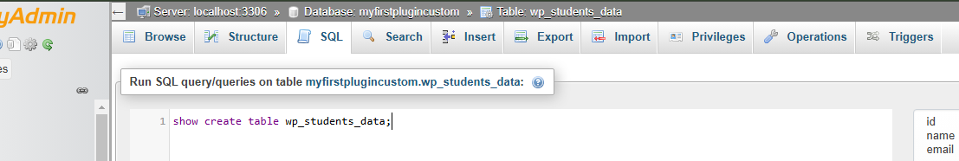

Now enter

Check Extra options

Fulltext and hit the Go

Now copy the Create table

In VS Code add tab and paste there

That is the complete create statement of this table This is the commad what we’ll use but in dynamic way to create our dynamic database table on plugin activation

> THIS TABLE WE HAVE TO CREATE IN DYNAMIC WAY

* THEN DELETE THAT TABLE IN PHP ADMIN THAT YOU CREATED
* NOW IN PLUGIN MAIN FILE

Things that we accomplished.

1. How to create a form using Shortcode (done)
2. How to create a dynamic db table on plugin activation (done)
3. How to add / use ajax request in plugin
4. Upload csv file read all data using code and save into dbtable.

**How to add / use ajax request in plugin**

Create **assets** folder and inside create a file **script.js**

* We create because we want to save or upload our CSV file using jQuery so we have to use the concept of jQuery inside this script,js file

In main file add Script file.’

To read the script file

Upload csv file read all data using code and save into dbtable.

CDU FORM

4. **Table data backup to CSV**

* how to ecport data into csv file,
* easily way to export into the phpmyadmnin and select csv file.
* But we want to do same function using plugin code
* Create another plugin called table-data-csv-backup the file under table-data-csv-backup.php

**Things todo**

* Create Plugin menu in admin
* Create a page a Button Export
* Export all table data into .csv file

After this Create a template folder add file for table data back up and a wp function button submit

read/get the file using ob start

Refresh then ths will be the result

Add method in your form and copy the name of submit wp functions

Then add actions

Run the button

It reads all the data and print.

Convert into **arrays of object** into **array of arrays** using **ARRAY_A** means associating array

Result is



Now Simply we have to read all the data and after it we have to put inside a file and save into .CSV extensions.



Simply we are reading the first value.

 

Now lets get all the contents

1. **Wordpress Custom Widgets**

* install generatepress theme
* this are customable widgets
* install classic widgets plugin > the layout of widgets will manage automatically. Change from block page to classic layout
* **CREATE CUSTOM WIDGETS INSIDE WORDPRESS USING OUR OWN CUSTOM PLUGIN**
* Create a folder my-custom-widgets and a file my-custom-widgets.php also add some description of a plugin.

**A code for another file for My_Custom_Widgets.php**

**Now Go and check the Custom widgets in plugin drag in side bar and check**

**Now theres no class in my widgets and I want the same as calendar**

**Inspect the input of the calendar and and copy the class to paste to custom code of al;l input in your custrom widgets**

**It gonna be look like this**

**Now notice that when you inspect the input of the calendar widgets there have an name and id attribute value. And in out custom widgets we don’t have.**

* **So how to get value and whats the pattern of that**
* **This is the easiest daw na concept sa wp**

**Now go to editor**

* <!-- Lets say that we want top generate the name and id  so simply we have to use two methods one for the name att and other for id att THIS MWTHOD WILL BE PROVIDED BY OUR PARENT CLASS CALLED WP_Widgets which is the class_wp_widget-->
* <!-- go look or search for get_field_name and get_field_id COPY and paste here for name and id using php and echo $this->get_field_name and add ('title') kasi title field sya  -->

**Now inspect and notice that we generate automatically id and name att**

**Sa for att pala ng label. Add also php sa taas for bot post and message.**

**//  <!-- copy the name att paste sa for att for label -->**

**NOTE THAT IS THE PROPER WAY TO WRITE OF THIS FORM METHOD TO DISPLAY OUR WIDGETS FORM TO ADMIN**

**NOW lets do if I select static it only show the message input and if I select Resent post it only show the number of post input.**

* **First we need javascript > create js file**
* **The add admin panel script to the main file**

**Format to jquery**

**Now test. Inspect and test the console and check view script look for admin-script id**



**Now add class in the SELECT**



**Copy and paste in script**

**Also add value on the options**



**Now check the console every time I select it conlose.log the value each.**

**NOW lets do if I select static it only show the message input and if I select Resent post it only show the number of post input.**

**Now we need css file > create style.css after include the style css to main file**



**Now create class in css.**

**Now copy the id of both input number post and message input > I note mo sya sa jQuery sa script.js**

**Note: ung p id ha di mismo ung input id nila kasi pag un lang un lang na hihide di ksama ung label**

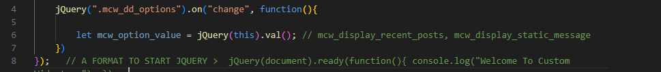

**Like ganyan magiging ganyan na**

**Now eto na ung codes**

**BUT MAY ISSUE PA YAN > if di pa satisfy check mo kung gumagana yan gamit console add ka ng console.log(here1) sa if sa else if naman console.log(here2) check mo mag select**

**Now fix the issue**

Just add for bot p tag kasi id sila ng p tag. p#tas ung id

Also add class sa recent post ng hide element para pag inopen naka hide sya

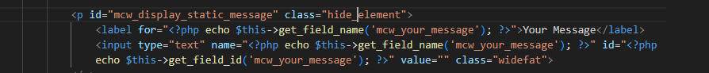

**NOW ITS WORKING!**

**Now lets do the**

1. **Save Widgets Settings to wp database**

**Notice nan aka save kana pero ung value di nang stick**

**To fix this**

**This.**

**In Option value naman**

**Add <?php if($mcw_display_option == "recent_post") { echo "selected"; } ?>**

In Order to display widgets to Frontend

1. **Wordpress Custom Widgets**

* We learnd about widgets, why we use widgets and the process.
* Well know the complete about widgets.

1. MetaBoxes
2. How to create Mb etabox in wp
3. Save metabox data to db table
4. Display Metabox data to frontend

If you want you metabox available only for the pages or posts add “page” or “post”.

Now we want to save the value

When you reload the page the value not showing but it remain in the db table.

Then

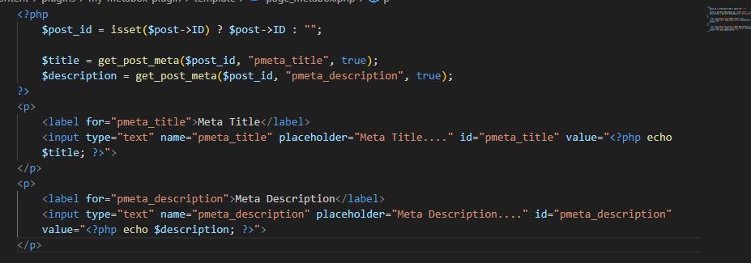

Add post id and add the value for title and descriptions



So those field will go to inside the head tag

Now id like to add two meta tags like the value of meta title and description.

Now add another action or hook



I add automatically.

Additionally

Try to updated the metabox

Look for data base



Nag update > now look for source code



1. **WP Admin Login Page Customizer**

* Well know the concept of settings fills inside WP and how to customize like LOGO, TEXT COLOR, BG etc….
* Learn how to control
* Create folder wp-login-customizer and main php file wp-login-customizer.php

Activate and check



Create separate files for layout

Check

**//Now create some settings field of this group wlc_login_page_settings_fields_group**

**// > create inside the main file**

**// Register Settings For login page**

Check if the layout saved

Notice that we have add_settings_section for the purpose of the tiltle and **Login Page Customizer Settings**

**Note naka table form sya**

**Create for Background color and Logo (same process of the setting field and functions)**

**Reload and check the final layout**

Now after we fill all the settings we are summiting all of the information using post request type > option.php so automatically this url or this handle all the data and save inside wp options table.

* In database we have wp_options
* Once we save the data those data will save inside wp_option table db



Try to fill and save settings and check if the value will saved automatically.





Now it will automatically save the value in the table of wp_option

If You reload the Login Page Customizer Setting all the value will Lost

We want that it’ll remain in the input



Now do it sa Background and Logo.

Now the value automatically remain in the input.\

Try to change and save if the function will work

Now we want to apply the setting to this page> the text color, bg color and logo.

Then save

The text color will change.



Notice some text doesn’t change the color to do that inspect and get the id or class.



Now the text will change automatically

Now change the background color

Now change the Page Logo

Logo change automatically.

1. **WP CRUD Plugin Development**

* Learn CRUD statements

1. Follow Class Based Plugin Develop ment

* Only to Create single file we didn’t use any concept of class

1. Create a DB Table
2. Deactivation Hook

* Means all the table and data that created simply we have to delete that

1. Create a Wordpress of Plugin Activation and also How to delete on Deactivation
2. Create a shortcode and put into page that we have created

* That shortcode will be dynamically put as a post content inside this created page

1. Follow ajax Concept as well as some DB Queries to perform CRUD Operation

* We have to do some ajax call by the help of that we’ll create some data and save inside our table and when we save any data simply we have to call another req to list all the data
* Create plugin folder wp-crud-employees and file wp-crud-employees.php

Create file for class based approach

Now create dynamic table

Then save

Next step we have to generate the create statement

Copy the table name go to sql. Plalitan mo ng **Show Create table wp_employees_table;**

Then click Go btn

Click extra option > full text > go

Now we have complete command to create a table.

Go and copy the commant and paste in vb.

Now inside this command we want to replace some values

* Replace table prefix ung wp_
* Then table name
* And collat value



Then replace some values. Especially the collate value

Then execute the table with dbDelta

Linked the file into main file

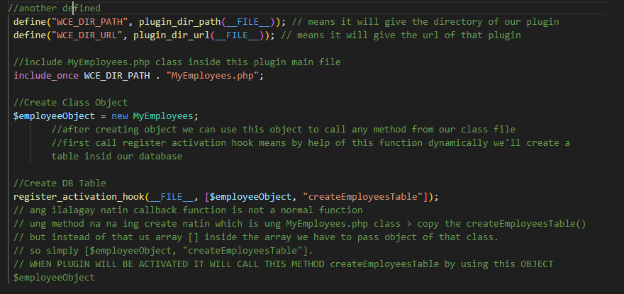

During activation found error



Fix the $wpdb to wpdb

NOW GO AND ACTIVATE THE PLUGIN

See if nadagdagan ng panibagong table



THE TABLE ACTIVATED USING PLUGIN ACTIVATION HOOK

Next once we deactivated the plugin we want also delete the table in Database

In MyEmployee.php add another public function

And register to the main file using register deactivation hook

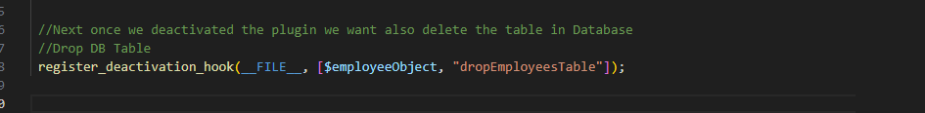

Now try if it drop automatically once we deactivate the plugin

NOW IT WORKS

Now we have an idea about register activation hook as well as register deactivation hook.

Next we Create a Shortcode and by the help of this shortcode we’ll display a form inside our public page.

* By the help of that form we’ll create some employees data and save inside our DB table

Now Create a shortcode



And add public function to Render the layout

Now try

Now it work but only static message.

We have to render a layout and inside the layout we want a form field

Add profile_image and a varchar of 220. 

Deactivate the plugin and activate then check then database



NOW INSTEAD A STATIC MESSAGE WE DISPLAY A FORM

Note we want to Create a page of plugin activation and inside that page we’ll have a dynamic content and that content is shortcode

Replace the



To

Means once na inactivate natin ung plugin mag create din ng wordpress page dynamically.

Then create a page dynamically

Go to wp_post



Now

Save file deactivate plugin and activate. > go to page check if the page created dynamically

View site > note the shortcode works properly

NOW INSTEAD OF A STATIC MESSAGE WE HAVE TO CREATE A LAYOUT

* Create a folder template > employee_form.php

In a singe page we have add Employee form and a list of employees

Cut all the content and create a div

Paste the content

Next link the file layout

Dito sya I lilink kasi un ung laman ng Shortcode natin. Which ung form

Now check if the layout saved > visit the link of page

The Layout is okay > to update the layout and have css > use chatgpt > copy the code layuout > “Please update our code and css to create eye catching layout . This page is a template and a part of wordpress frontend page.” Chat gpt provide css and update the code. Copy the css and include style at the top and paste.

The layout look like this if its provided by CSS

Now we have add employee form the now this form will be submitted using ajax request

Now we need to create a style.css to separate all the css code and also we want script.js file.

* Create a folder assets > create a file style.css and script.js

Cut all the code of style tag in the laypout and paste in style.css

Also add script

Now linked the style.css and script.js to the main file



Check if the style and Script are working

Now we have a form but no implementation of Validation

* Implement all about the concept of plan side validation using jquery plugin file.
* Search validate.min.js (<https://jqueryvalidation.org/>) > choose for demo

The “*This field is required*” that is the validation we want to implement in our form

* View source code > look for script jquery.validate.js ("[../dist/jquery.validate.js](https://jqueryvalidation.org/files/dist/jquery.validate.js)) > the llink about is the CDN link of that library file (<https://cdnjs.cloudflare.com/ajax/libs/jquery-validate/1.19.5/jquery.validate.min.js>)
* Or simply search for validate.min.js cdn > it provide links for cdn
* Instead of linking, download the file> right click and save file sa assets. And call inside our plugin file.

Save it into assets folder para ma call sya

Add **required** attribute sa mga inputs.

then add validation sa script.js

Check if validation is okay sa form

Validation is working > go and style color red in style.css

Now after this form validation we work for ajax request.

**AJAX REQUEST PROCESS**

* First we want ajax URL.

Check sa viewsource kung pumasok



You see we have an object and inside the object we have single propery “**ajax_url**” and have a ajax url “"**http:\/\/myfirstplugincustom.test\/wp-admin\/admin-ajax.php**"”.

Now next we have to work over the form submission code so the the form data will be submitted using ajax request file and save inside our data table

Now copy the form id and go to script,js

Note: add another input type hidden sa form sa taas

In main file add action for process ajax request

The add public function

Now check if the ajax process properly in network

**Summary to Process ajax request and connect to Form data submmition**

* To process database form you need ajax url using link that and based for script link (Ajax url  >using wp funtion wp_localize_script)
* Then connect to Form submit in js simply copy the form id and do the process using (jQuery("#frm_add_employee").on("submit", function(event))
* Also you need add another input type hidden para sa action because we want to capture this ajax request inside wp and process all those data
* Then Process ajax request using action “add_action("wp_ajax_wce_add_employee", [$employeeObject, "handleAddEmployeeFormData"] );” "wp_ajax" is the action hook and "wce_add_employee" eto ung value name ng hidden input.
* Then add plublic function sa MyEmployee.php to Process Ajax Request: Add Employee form and do the process. Then check and try to submit

SIMPLY BY THE HELP OF THIS DATA WE HAVE TO CAPTURE ALL THOSE DATA IN FORM INSIDE THIS METHOD AND NEXT SAVE INSIDE OUR DATA TABLE

**Save data value into DATABASE**

Check if the data value save into database table

Now Successfully saved value

**THE CONCEPT TO SAVE PROFILE IMAGE URL/PATH**

* Once we upload the profile image of any employee **this image first should be upload inside upload directory**
* Upload directory located to **wp content > upload**  means jan sya mag sasave
* And get a path/url of that image from that upload folder and save that url into database table column.

NOW

**The meaning of this $fileUploaded = wp_handle_upload($_FILES['profile_image'], array("test_form" => false));**

The add profile_image

Now check try upload again if the path value saved successfully in db table



And also for upload folder the image also save

Now display **Message alert Successfully** uploaded at the top

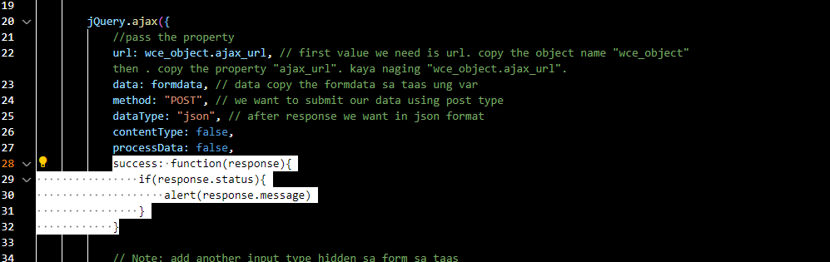

In Script.js in success add alert function

Now try and create one more employee check if the alert popup

**NOW WE SUCCESSFULLY COMPLETE THE FUNCTION FOR CREATE EMPLOYEE DATA AND SAVE INSIDE THE DATABASE**

**READ**

Next whenever we save any employee in the form we want that all those employees should be listed inside List employees table.

* To do. We have to make an ajax request and by the help of that we have to call that function to load all employee table inside this List of employee table

Make ajax request, for load all employees from db table

And Render Emloyees using call that function name inside

Copy the action name value which is wce_load_employees_data then add_action

PUBLIC FUNCTION

Go to page and console

NOW By using this function when it called loadEmployeesData();

The function is going to load all the data inside our console tab

Like this

Now if you got to Network

Header and check for method



Then inside payload

the action name

And in preview we have all those data

  // after getting all those data we have to bind this data to our table

    //COPY/CUT THE <tr> Tag in html form and add id sa tbody "employees_data"

And in script.js paste inside the comment

NOW SET ASIDE

Now in the success inside the function loadEmployeeData

Ganyan ung format pag mag console ka ng name

Go to console\

It return all the name in db

Now we get the data for each we have to use the format <tr> to get all the data, name, email, designation and profile image

Now we need to assign employeesDataHtml and paste the <tr> body inside.

Change the assign for every td

Also add  data-id="${employee.id} for both button edit and delete

BIND THE DATA

And see the results

Now we get the data and all this data coming from our database table

Try add some data

Also in success inside add employee function jquery after allert add  loadEmployeesData(); // Reload the List table function data

**NOW NEXT BINDING FOR IMAGE**

* We have to use image tag and what the data we get inside our image url we have to bind that data with that image tag
* Also we have to check that if image exist the its okay otherwise this is a valid

Now check add data then save

Results

Pag null “—” ganyan lang.